 ERIC G. SUMMONS

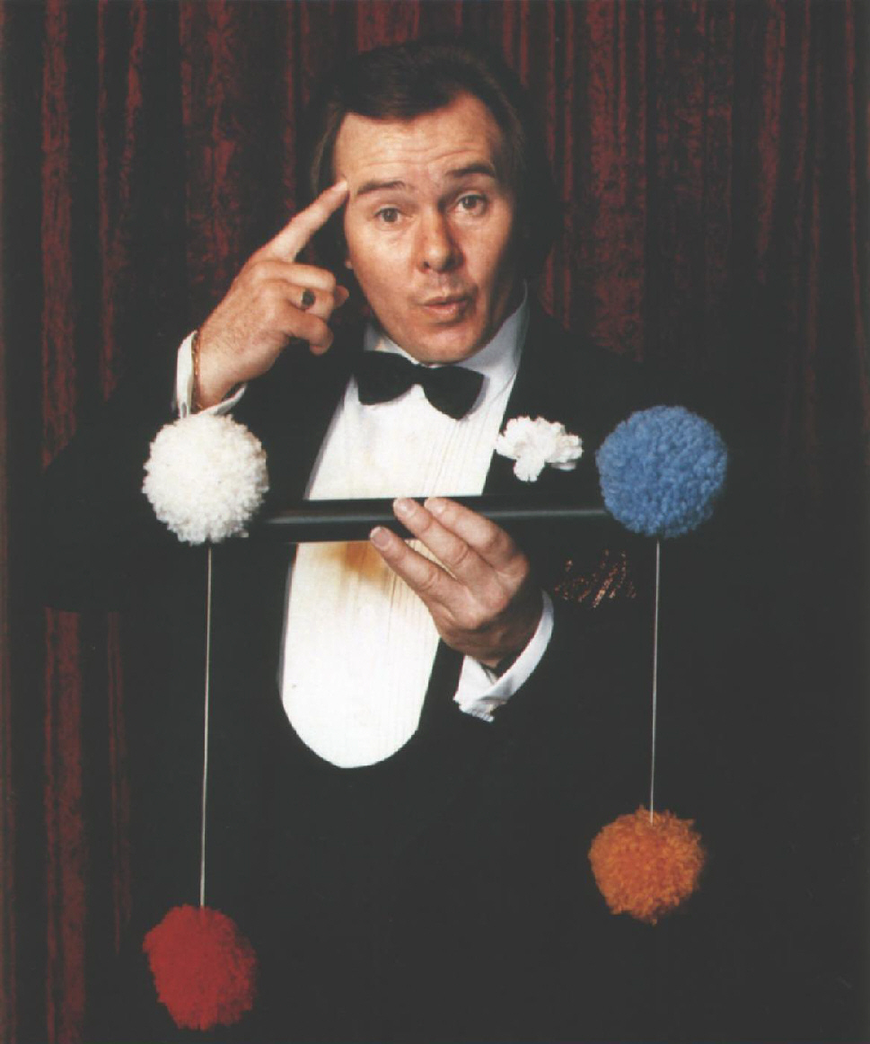
THE
COMPLETE ENTERTAINER

Combine natural talent with many
years of experience and what have
you got.....

ERIC G. SUMMONS

Comedian | Compere | Magician
Singer | Actor | Speaker
Producer | Director | Writer

PERFORMING

Television Radio Cabaret Theatre
Trade Shows Exhibitions Corporate
Circus Shopping Centers Restaurants
Fairs Fetes Schools Clubs
Casinos Private Parties Close Up
After Dinner Company Functions
Sporting Events Cruises

AWARDS
17 Entertainer of the year awards.
Most versatile performer of the year.
Comedian of the year.
Compere of the year.
Sight act of the year.
Theatre restaurant performer of the year.
National Critics award for comedy.
Numerous T.V awards, Sammys, Logies, Penquins.

WHEN AND WHERE
Eric has completed many world tours, performing in 22 countries appearing in the top international hotels, American, English, European and Australian Casinos, and numerous leading nightclubs including the Playboy circuit.

He has clowned on ice and in many international circus shows.
He has produced and performed on many of the top ocean liners working as a cruise director for Chandris Lines for over 3 years.

He has produced and performed in several top Australian theatre restaurants over eighteen years.
He was part of the famous London "Magic Circle" performing team.
Most of all Eric is well known for his television shows. Firstly as Producer and compere of "Boris' Breakfast Club", Australia's top rating morning show for over sixteen years and secondly as producer and compere of Australia's Award Winning afternoon show "Wombat".

Apart from the many varied character roles he played on these two shows, he also was the resident character actor on the T.V show "Top Of The Bill"

Add to this several "Magic" specials that he produced and starred in and you end up with a very successful television career.

SOME OF THE MANY FACES OF
ERIC G. SUMMONS
- BORIS THE BLACK KNIGHT
- IVOR THE INCREDIBLE
- DETECTIVE SUMMONS
- LOLIPOP THE CLOWN
- ZERO THE WIZARD
- W. C. FIELDS
CHARACTERS CREATED FOR ANY OCCASION
What the papers say.....
".....Then Eric Summons, who delighted us all, a fresh and ingenious act with an enormous rate of laughs per minute. He’s natural wit and personality has made him a great hit with audiences all over the world." Bayard Grimshaw. "World Fair"

"There is a magic in this act, for Eric Summons bites with the sharp teeth of wit and originality. Alan Kellaugh. "T.V Times"

"Eric Summons produced a brilliant piece of work, a real bellylaugh. It’s what you might call a summons that’s hard to resist." Brian Johnston. "Sunday Sun"

"But in every show there is a star act, and this one is no exception. That star was Eric Summons doing a comical magic act. It had the whole audience literally rolling in the aisles with mirth, and believe you me, it is many a long day since I saw such a screamingly funny act." David Tickell."Telegraph"

"Eric Summons is hilariously funny in so many ways. He’s act is fresh, original and cleverly contrived." David Tickell."Telegraph"

Eric Summons, is...."King of the Kids" | Veritas. "The Sun"

For Bookings Contact:

